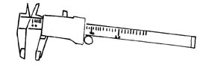
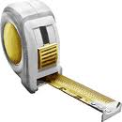
LASS-SPH3U Measurement Principles- Part I

Measurement Error
Measurements are NEVER exact. There is always an uncertainty or “error” in any
measured value. If several people measure the length of the same table using a metre stick, it is normal for them to get slightly different values.

RANDOM ERRORS- are due to random and unknown changes in experimental conditions and include factors such as fluctuations in the quantity being measured, and external electrical noise. Limitations in the resolution of the measuring device can also contribute to estimation error.

SYSTEMATIC ERRORS- are due to an inherent problem with the measuring device, such as an error in instrument calibration, or an error in how the device is used.

Measurement Uncertainty
Measurements should be made carefully and should indicate how confident you are of the measurement by stating the measurement uncertainty. The measurement uncertainty indicates the range of error in your measurement.

For example, a measurement of 5.4 ± 0.1 cm indicates that the actual value could lie between 5.3 cm and 5.5 cm. Notice that the uncertainty of ± 0.1 cm shows we are not certain of the “4”-it is an estimated digit. Similarly, a measurement of mass of 16.25 ± 0.01 g indicates we are uncertain of the last “5”-the actual value could lie between 16.24 g and 16.26 g.

Practice 1: State the range in possible values for each measurement below:
a) 56.85 ± 0.01 g : ____________________ c) 21.6 ± 0.2 s : _______________ b) 15.9 ± 0.1 cm :_____________________ d) 7.200 ± 0.001 g: ______________

Determining Uncertainty: When performing a measurement, the uncertainty should reflect the resolution of the instrument and the conditions under which you are performing the measurement.

Both a ruler and a metre stick have scale markings of 1 mm but the uncertainty associated with measurements made with these two devices may differ. When using a ruler to measure a small object with sharply defined edges, you may be able to use a ruler to estimate between the millimetre scale markings to the nearest ½ mm (± 0.05cm).

If you are using a metre stick to measure a large object with edges that are not clearly defined, you may be only able to estimate to the nearest 2 mm to give a measurement uncertainty of ± 0.2 cm.

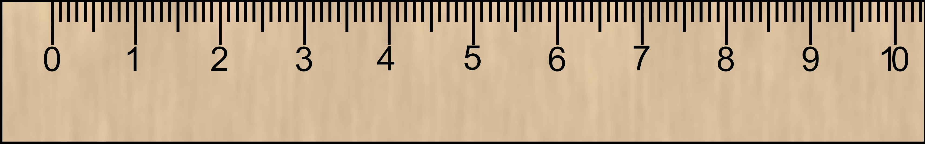
Practice 2: Determine the length of the arrow below using the given ruler. Make sure to state your uncertainty!
cm

Measurement: ___________________________________
Significant Digits or “Sig Digs”
Significant digits are all the digits in a measurement of which we are reasonably certain. This includes:
ALL OF THE DIGITS ABOUT WHICH WE ARE CERTAIN
PLUS THE LAST ESTIMATED OR UNCERTAIN DIGIT!

All digits in a measured number are significant EXCEPT
leading zeros for decimal numbers (as they are placeholders)
trailing zeros for whole numbers (as they are placeholders)

Examples; 45.005 m – has 5 Sig Digs
0.0629 g –has 3 s.d.
7.8450 s – has 5 s.d.
5670 km –has 3 s.d.

Avoiding Confusion with Whole Numbers:
Confusion regarding the number of significant digits in a measurement can occur if the number is recorded as a whole number. For example, the measurement of 5670 km could have 4 significant digits if it was measured to the nearest kilometre. It could also have 3 significant digits if it was measured to the nearest 10 kilometres.

Scientific notation is used to avoid confusion!
Ex. 5.670 x 10³ km indicates the measurement was made to the nearest kilometre.

5.67 x 10³ km To indicate a measurement made to the nearest 10 kilometres:

Counted and Defined Values
These kind of values are exact and are considered to have an INFINITE number of
significant digits.
Examples: 27 students in class conversion factors: 100 cm/m
10 cycles of a pendulum defined values : π (pi)

Practice 3: Represent a measurement of mass which was written down as 5200 g to indicate that it was:
i) Made to the nearest gram : ________________________
ii) Made to the nearest 10 grams: ____________________
iii) Made to the nearest 100 grams: ___________________

Practice 4:
Indicate the number of significant digits in the following measured quantities:
a) 5.2 m _______ b) 245 kg ______ c) 999 s ______ d) 0.3 cm ______

e) 0.125 mm _______ f) 0.0035 km _____ g) 0.608 g ______ h) 3005 m _____

i) 450 m _______ j) 7.80 x 10²m _____ k) 1.030 x 10³ km _____
Accuracy and Precision:

We use the terms accuracy and precision to describe how well we have made a measurement.

Accuracy: Refers to how closely a measurement agrees with the actual value. Without
knowing the "true" value of a quantity we may not be able to assess a
measurement's accuracy.

Precision: Refers to how finely a measurement is made. When comparing two measurements
with the same units, it is determined from the place value of the last digit.

For example, a measurement of 6.384 m is more precise than a measurement of 6.4 m. The first measurement is made to the nearest 1/1000th of a metre (to the nearest millimetre) while the second is made to the nearest 1/10th of a metre (to the nearest decimetre).

Precision may also refer to how predictable repeated measurements are.

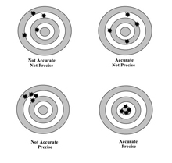
We can understand the difference in these two concepts by using a target shooting analogy. Imagine that arrows shot at an archery target represent repeated measurements of the same physical quantity. The “actual” value is represented by the bulls eye. It is possible for a set of measurements to be precise (clustered close together) but not accurate (not centered on the bulls eye). Conversely, a set of measurements can be accurate on average (centered around the bulls eye) but not precise (not close together).

